SPECIAL EDITION
OUR NATIONAL SUMMER GAMES
BIRMINGHAM 2026
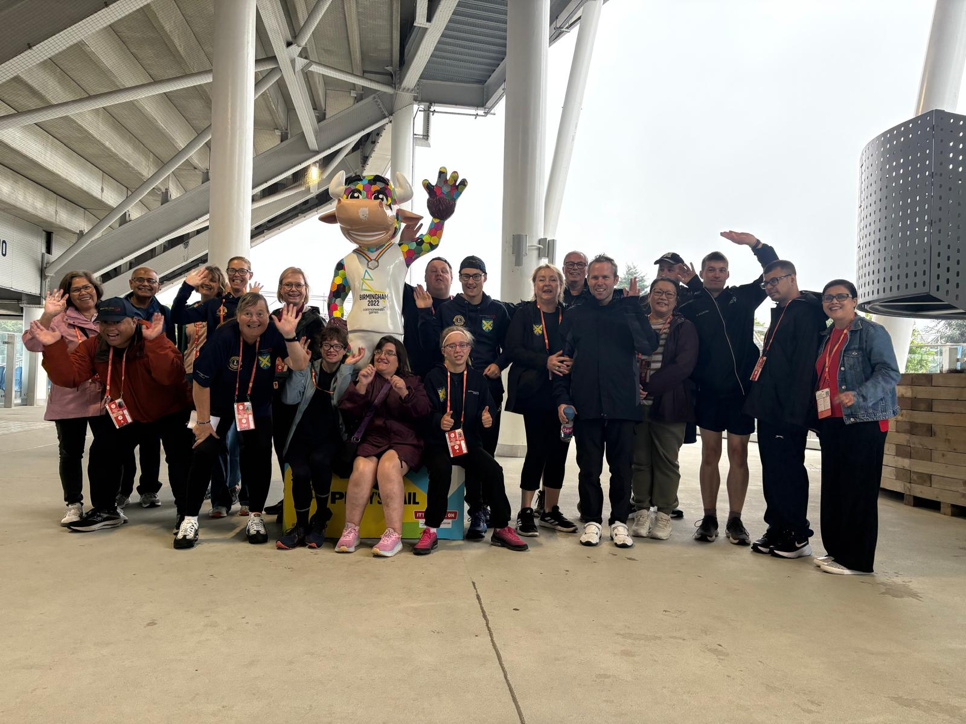
Team SOSA together in Birmingham
6  SWIMMERS IN RESULTS | 11  SWIMMING GOLD | 4  SWIMMING SILVER | 2  SWIMMING BRONZE
What a Games! Our St Albans athletes brought determination, friendship and brilliant team spirit to the Special Olympics GB National Summer Games in Birmingham. Every start, finish, personal challenge and podium moment made us enormously proud.

A message to our SOSA family
To our athletes: congratulations. You trained hard, competed with courage and represented St Albans superbly. Your smiles, support for one another and willingness to give your very best captured everything that Special Olympics stands for.
To our parents and carers: thank you for making the journey, managing the early starts, cheering from the stands and giving such patient, practical and emotional support throughout the Games. Your encouragement made these achievements possible.
To our coaches and volunteers: thank you for your preparation, calm guidance and countless hours behind the scenes. The team’s success belongs to every person who helped our athletes feel ready, confident and included.
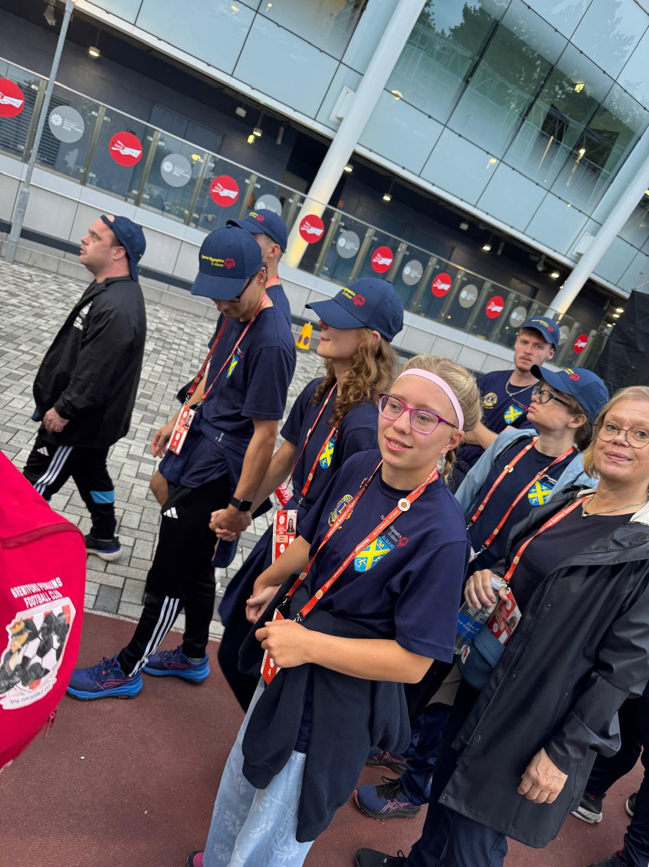 | 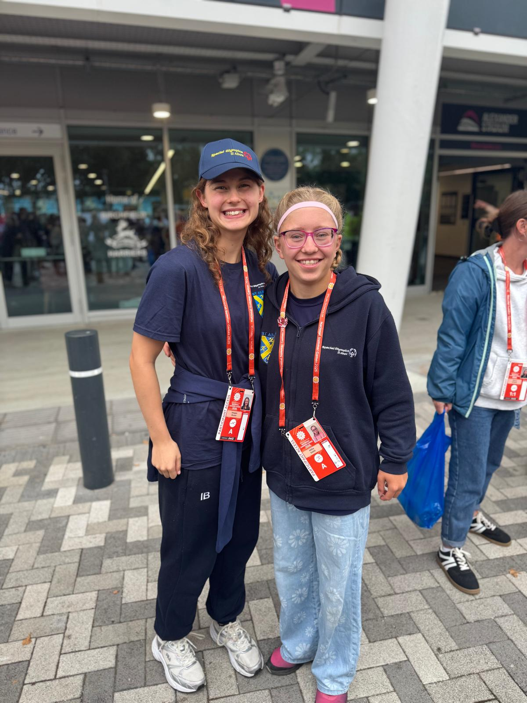
Proudly joining the athlete parade | Friendship and smiles at the Games

The SOSA swimming medal table
Athlete | Gold | Silver | Bronze | Total
Imogen Brown | 2 | 2 | 0 | 4
Mark Johnson | 3 | 1 | 0 | 4
Joe Edwards | 2 | 1 | 0 | 3
Philip Nicholls | 3 | 0 | 1 | 4
Nicholas Badinski | 1 | 0 | 1 | 2
George Patterson | 0 | 0 | 0 | 0
Team total: 10 gold • 4 silver • 2 bronze | Relay medals are included for each SOSA athlete in the winning team.

Results and achievements
The table below brings together the SOSA results recorded across the five supplied swimming result sheets. Placings are within the stated division or final. DSQ results are shown openly as part of the full competition story - every athlete’s effort and courage matters.
Athlete | Event | Result
George Patterson | 25m Freestyle | 5th
George Patterson | 50m Backstroke | DSQ
George Patterson | 50m Freestyle | 4th
Imogen Brown | 100m Individual Medley | Gold
Imogen Brown | 100m Freestyle | Silver
Imogen Brown | 50m Freestyle | Silver
Imogen Brown | 4x50m Freestyle Relay | Gold
Joe Edwards | 100m Individual Medley | Silver
Joe Edwards | 100m Freestyle | 4th
Joe Edwards | 200m Breaststroke | Gold
Joe Edwards | 4x50m Freestyle Relay | Gold
Mark Johnson | 100m Breaststroke | Gold
Mark Johnson | 100m Individual Medley | Gold
Mark Johnson | 100m Freestyle | Silver
Mark Johnson | 4x50m Freestyle Relay | Gold
Nicholas Badinski | 25m Butterfly | DSQ
Nicholas Badinski | 50m Freestyle | Bronze
Nicholas Badinski | 25m Freestyle | Gold
Philip Nicholls | 50m Breaststroke | Gold
Philip Nicholls | 25m Breaststroke | Bronze
Philip Nicholls | 50m Freestyle | Gold
Philip Nicholls | 4x50m Freestyle Relay | Gold

Athletics medal table
Our athletics team delivered an outstanding series of performances across track, field and relay events. Congratulations to every athlete for representing Special Olympics St Albans with determination and pride.
Athlete | Event | Heat | Result / Medal
Jethro Offemaria | 800m Track Event | Heat 2 | Gold
Daniel Edgington | Track Event | Heat 7 | Silver
Millie Smith | Long Jump | — | Gold
Anna Tencor | Standing Long Jump | — | Gold
Rebecca Somerset | Standing Long Jump | — | 4th Place
Michael Thurgood | 50m | — | Silver
Daniel Edgington | Long Jump | — | Bronze
Millie Smith | 100m | Heat 3 | Bronze
Team Relay | 4 x 100m Relay | — | Gold

Athletics medal summary
4  GOLD | 2  SILVER | 2  BRONZE | 8  TOTAL MEDALS
Boccia
Emre and Robbie formed our Individual Boccia team for some nail-biting games, with Emre picking up fourth place and Robbie a fifth is a hotly contested division. Huge thanks to parental support from Feray and Agata for making the trip and being there every step of the way. Hopefully we can plan towards hosting our own Boccia event once we have recovered from this one!

A fantastic achievement for Special Olympics St Albans at the National Summer Games - congratulations to all of our athletes!

Athletes in action
Across athletics, swimming and boccia, our athletes competed with focus, determination and joy. Every performance was cheered on by a wonderfully supportive SOSA crowd.
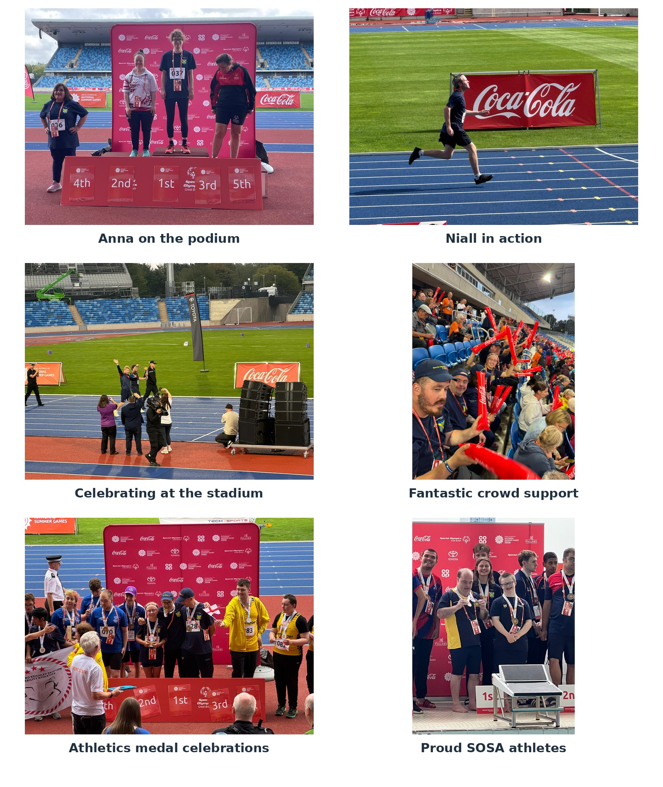

Podium pride
These brilliant medal moments capture the pride, excitement and sense of achievement shared by our athletes, coaches, families and friends.
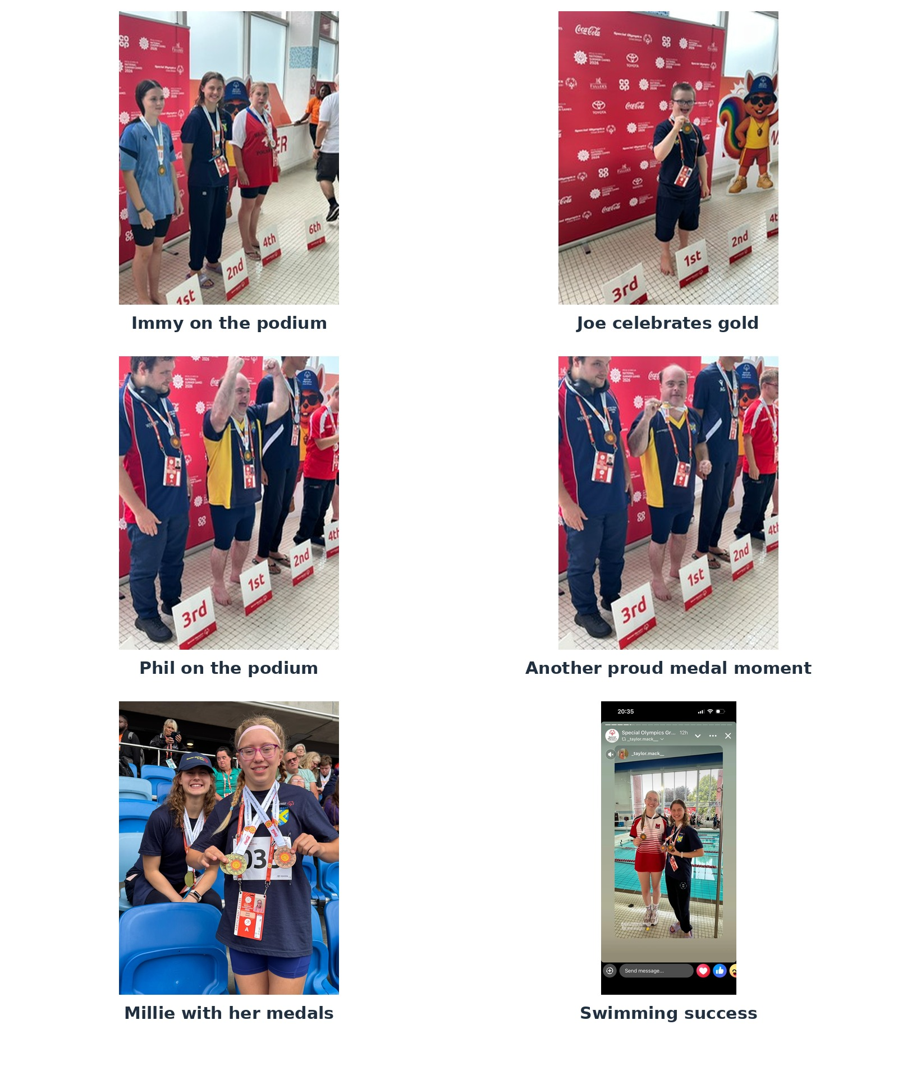

Teamwork across the Games
The Games brought together athletes from different sports and celebrated every placing. The friendships, encouragement and team spirit were every bit as important as the medals.
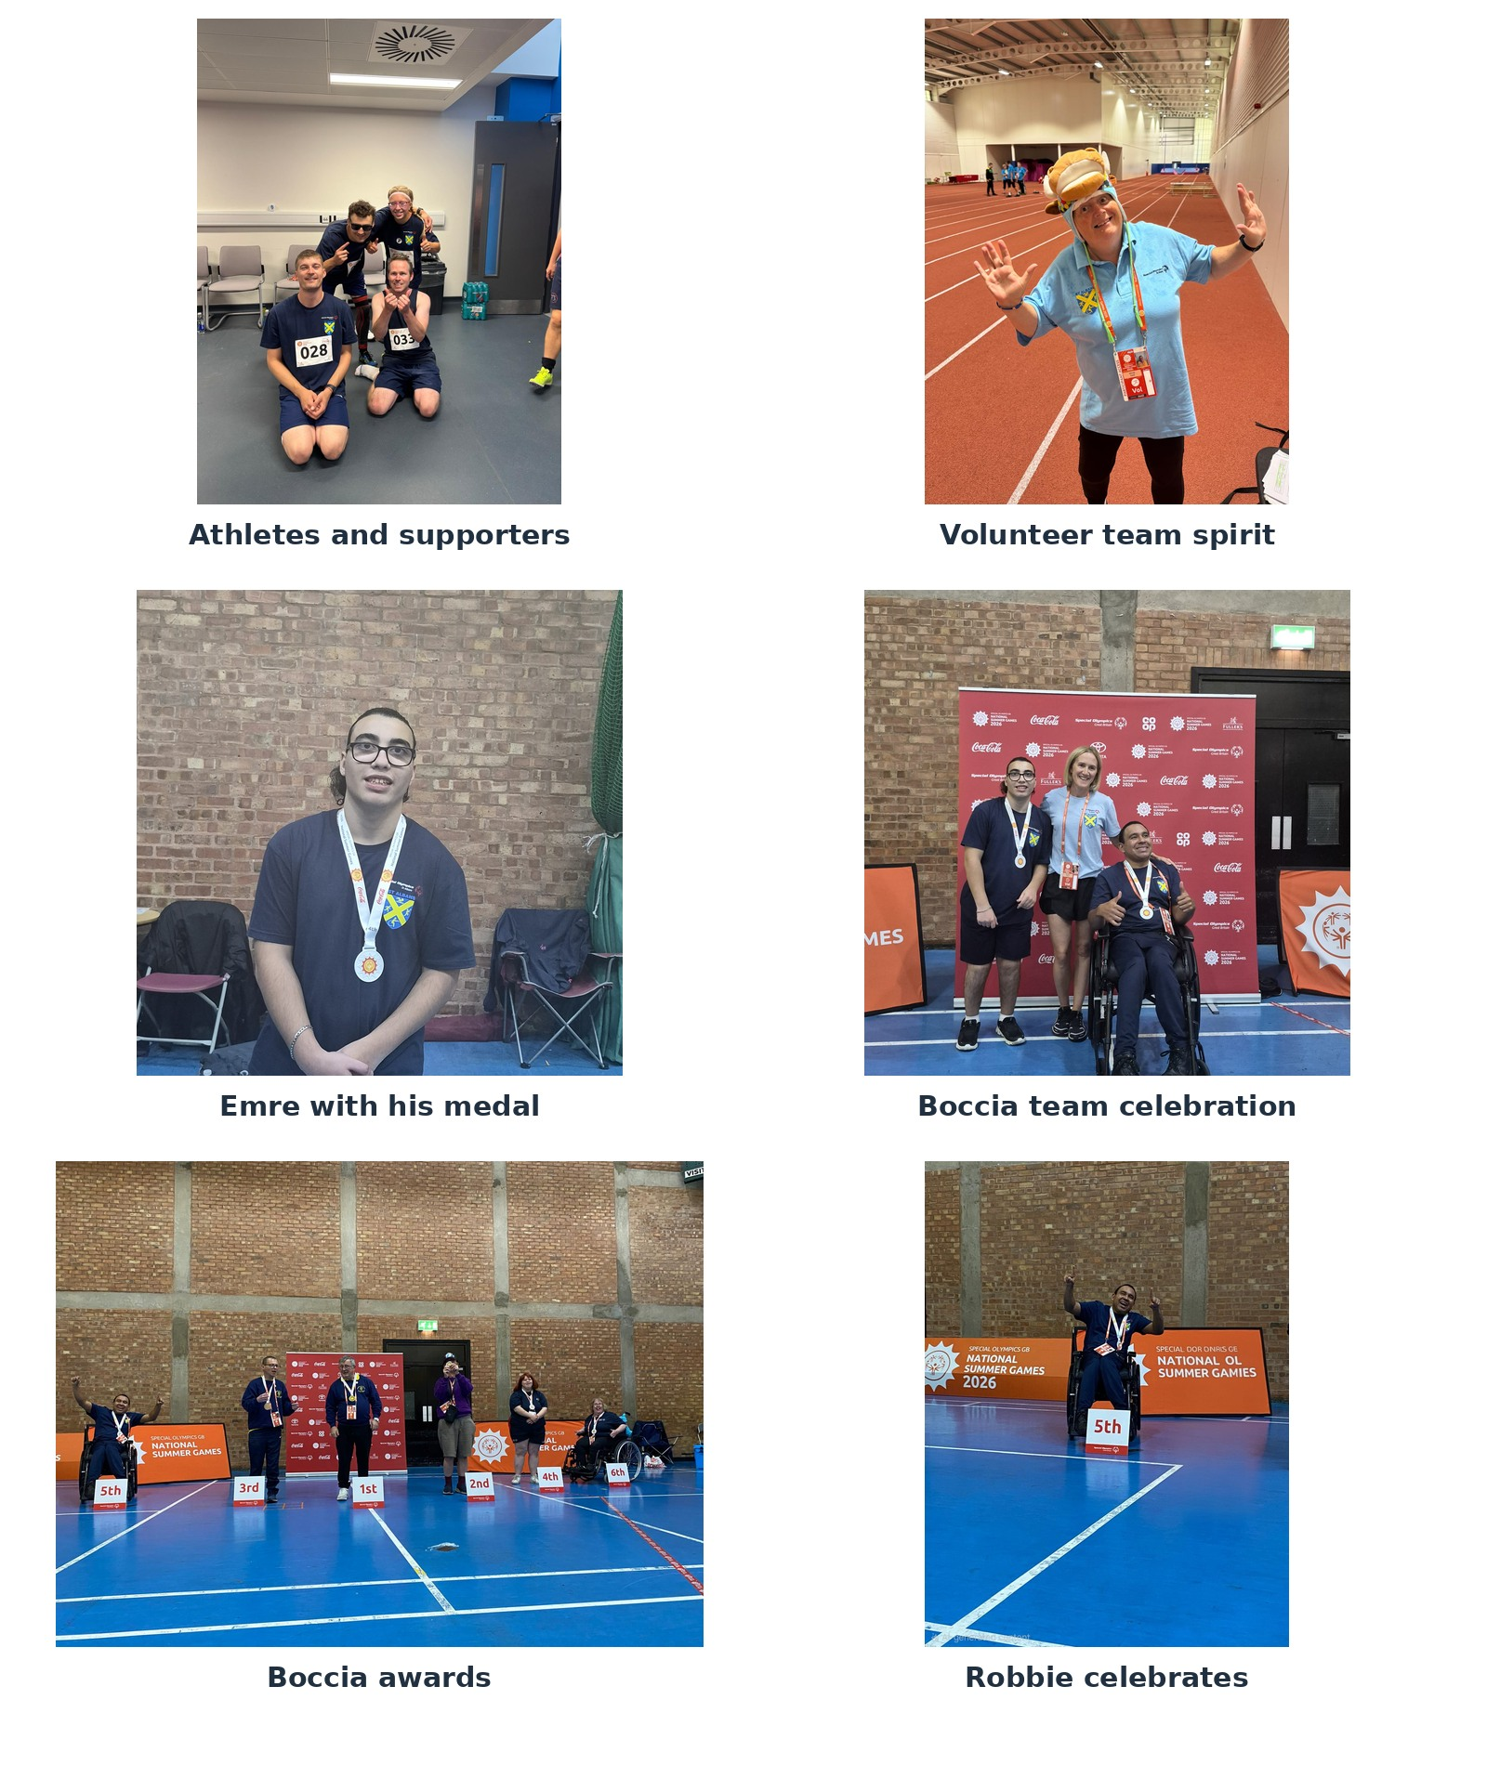

More than medals
The numbers tell only one part of the story. The Games were also about independence, confidence, new friendships, supporting teammates and creating memories that will last long after the final event.
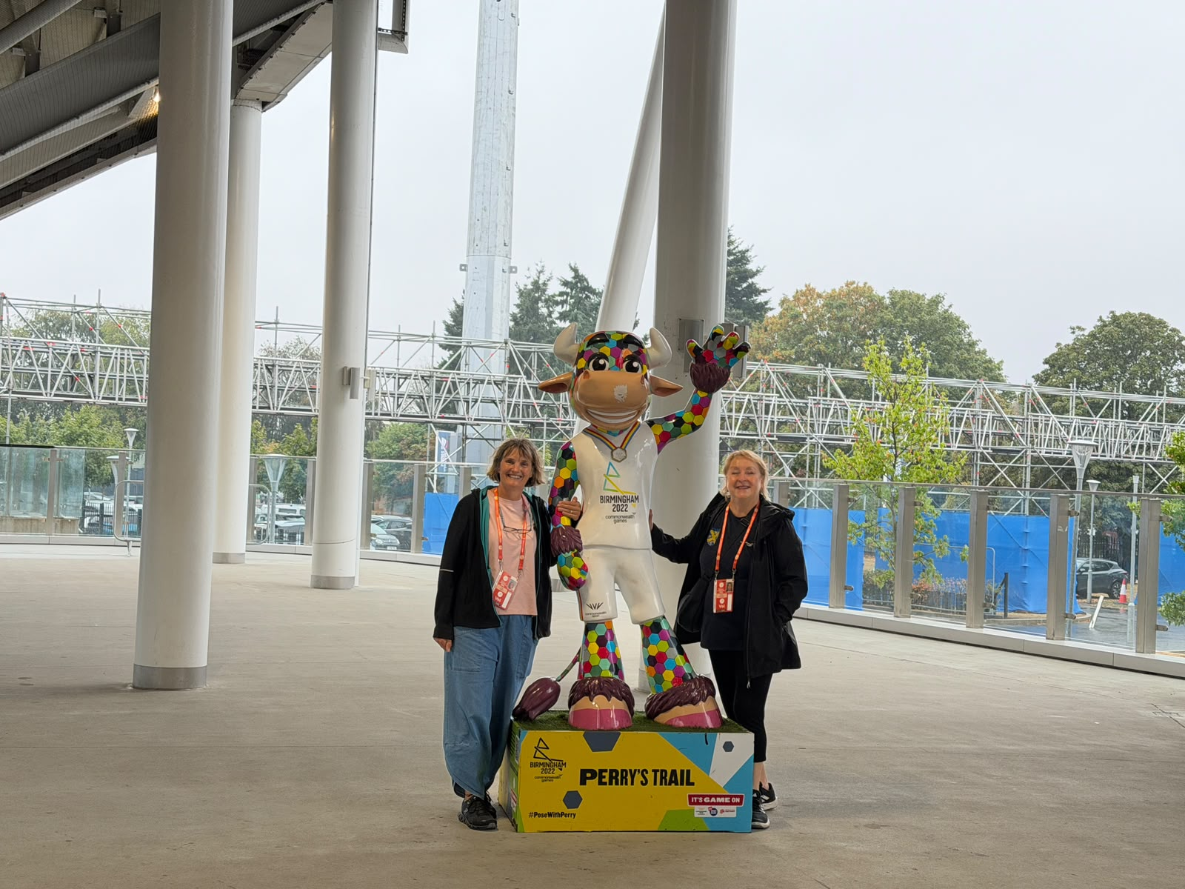 | 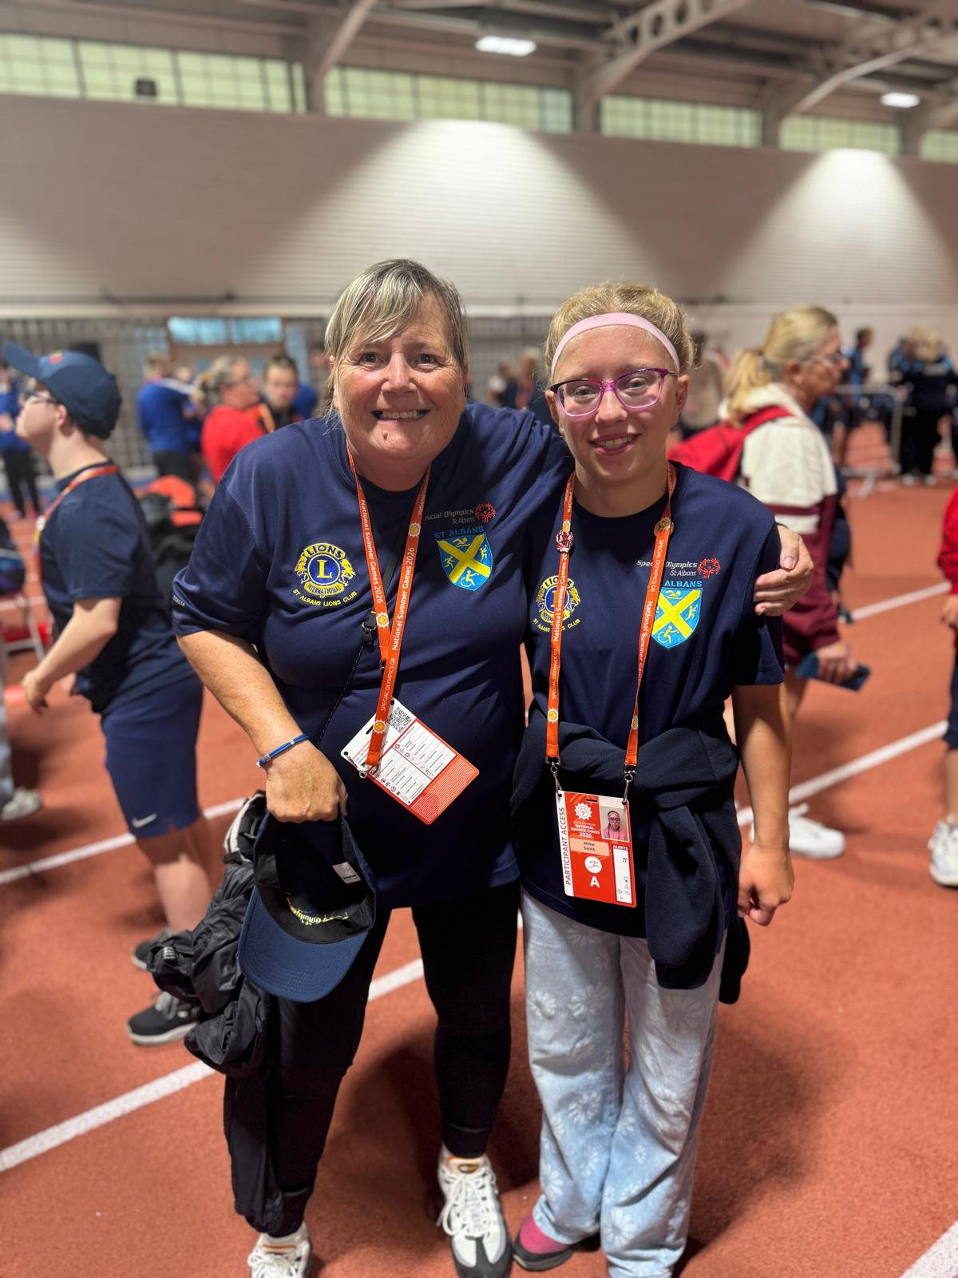
Together with Perry at Alexander Stadium | Support, smiles and special memories

Moments to remember
From the excitement of the athlete parade to the focus of competition and the joy of celebrating together, Team SOSA embraced every opportunity. We hope every athlete feels proud of what they achieved - whether that meant winning a medal, completing an event, overcoming nerves or cheering on a teammate.
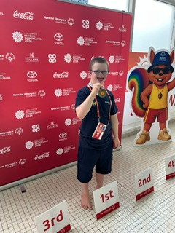
A proud podium moment
THANK YOU, TEAM SOSA!
Athletes • Parents • Carers • Coaches • Volunteers
We are incredibly proud of you all. Thank you for representing Special Olympics St Albans with such warmth, courage and team spirit.

